UNITED STATES DISTRICT COURT
NORTHERN DISTRICT OF ALABAMA
Choose an item. DIVISION

Plaintiff(s)., )
)
Plaintiff(s) )
)
vs. ) Case No. Case Number.
)
Defendant(s)., )
)
Defendant(s) )

O R D E R

On [DATE OF TRIGGERING EVENT] the [PARTY] filed a[n] [MOTION TO DISMISS, MOTION TO REMAND, or ANSWER]. (Doc. Document Number.). Pursuant to the General Order For Referral of Civil Matters to the United States Magistrate Judges of the Northern District of Alabama, dated January 2, 2015, the parties are hereby notified that, unless they unanimously consent to the exercise of dispositive jurisdiction by a magistrate judge pursuant to 28 U.S.C. 636(c) by no later than [DATE 45 DAYS AFTER DATE OF TRIGGERING EVENT], the case will be reassigned to a randomly-drawn district judge for all purposes. In the absence of consent by all parties, the Clerk is hereby DIRECTED to reassign the case without further order after [DATE 45 DAYS AFTER DATE OF TRIGGERING EVENT].

The parties are directed to use the magistrate judge consent form on the CM/ECF system to elect or decline the exercise of magistrate judge jurisdiction. Unlike in the past, a party can now complete the consent form electronically and submit it through the Courts CM/ECF filing system at the following web address: https://ecf.alnd.uscourts.gov. If a party submits the form electronically, the form will be delivered directly to the Clerk. It will not be filed on the docket sheet, and no judge will have access to the form. Alternatively, a party may print the form, complete it manually, and submit it to the Clerks office. A failure to complete the form and submit it, either electronically or manually, to the Clerk will result in the case being reassigned after [DATE 45 DAYS AFTER DATE OF TRIGGERING EVENT].
You may withhold consent without adverse consequences. The identity of any party who consents to magistrate judge jurisdiction will remain unknown to the undersigned unless consent is unanimous. The undersigned will only learn of a partys election to consent where all parties have consented. In the event fewer than all parties elect to consent, the Clerk will not inform the undersigned of the identity of the non-consenting party/parties. If all parties consent, a magistrate judge will exercise full and final dispositive jurisdiction, and all appeals will lie directly with the appropriate United States Court of Appeals.

DONE and ORDERED this __ day of _____, 20__.

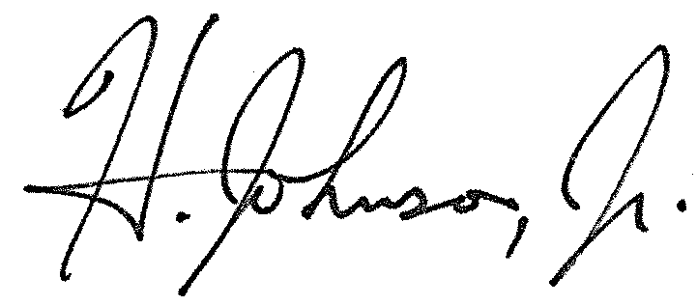
____________________________________
HERMAN N. JOHNSON, JR.
UNITED STATES MAGISTRATE JUDGE

