UNITED STATES DISTRICT COURT
NORTHERN DISTRICT OF ALABAMA
Choose an item. DIVISION

Plaintiff(s)., )
)
Plaintiff(s) )
)
vs. ) Case No. Case Number.
)
Defendant(s)., )
)
Defendant(s) )

O R D E R

The Court SETS a telephone status conference for [TIME] on [DATE APPROXIMATELY 30 DAYS FROM TRIGGERING EVENT]. The Court DIRECTS the parties to dial 877-336-1829 and enter access code 1205409 to participate in the status conference. If all parties submit an executed consent form before the date of the status conference, the Court will cancel the status conference.
DONE and ORDERED this ____ day of _____, 20___.

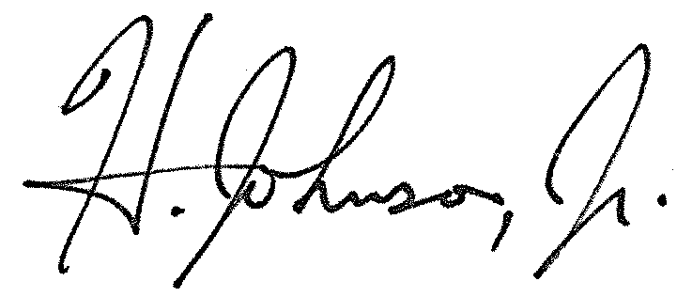
____________________________________
HERMAN N. JOHNSON, JR.
UNITED STATES MAGISTRATE JUDGE

