UNITED STATES DISTRICT COURT
NORTHERN DISTRICT OF ALABAMA
Choose an item. DIVISION

Plaintiff(s)., )
)
Plaintiff(s) )
)
vs. ) Case No. Case Number.
)
Defendant(s)., )
)
Defendant(s) )

ORDER REGARDING
COMPLIANCE WITH RULE 26

The parties are reminded to conduct a conference pursuant to Rule 26(f) of the Federal Rules of Civil Procedure. The parties must confer no later than twenty-one (21) days after the entry date of this order. During the Rule 26(f) conference, the parties discussions shall cover the following topics:
the nature and basis of the claims and defenses and the possibility of a prompt settlement or resolution of the case through formal mediation or informal settlement negotiations;
a proposed discovery plan, including deadlines for the matters addressed in sub-paragraphs (1) through (4) of Rule 26(f) and a protocol to govern the search and production of electronically stored information; and
the need for a protective order for disclosure of protected health information.
If the parties are unable to agree upon a date, time, or place for the Rule 26(f) conference, the parties are ORDERED to file a joint notice with the court.
Additionally, unless otherwise ordered, the parties shall exchange the initial disclosures required under Rule 26(a)(1) at least seven (7) days before the meeting in order to facilitate better discussions during the discovery conference. Within fourteen (14) days of the Rule 26(f) meeting, the parties must file a joint report of their planning meeting. The report should include a brief description of the nature of the case; an indication of the parties assessment of the complexity of the case; proposed deadlines for amending the pleadings, joining additional parties, discovery, and dispositive motions; and a statement regarding the parties initial interest in alternative dispute resolution. Should the parties disagree about an item, the positions of the parties as to that item should be clearly set forth in separate paragraphs.
DONE and ORDERED this __ day of ________, 20__.

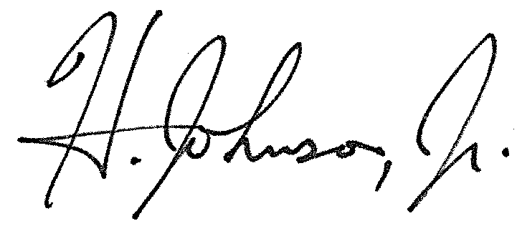
____________________________________
HERMAN N. JOHNSON, JR.
UNITED STATES MAGISTRATE JUDGE

If the courts standard HIPAA protective order is required, the parties may indicate this in their joint report of planning meeting. If the parties require a HIPAA order tailored to the case, the moving party should email a proposed draft order to the chambers email address upon the filing of a motion.

